**Expanding your Map Horizons**

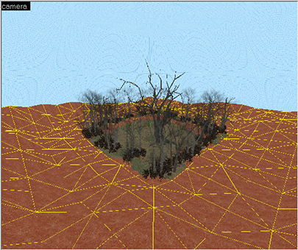If you have been following along, then you may notice that our map is actually too small for a proper forest. In fact you really only have room for one row of trees, and not room for hordes of zombies to spawn. Making a map to the proper scale is an issue that you will run into when making your own maps. So we will now expand our map to that it is twice as wide and long--**4092x4092** units. The easy way to do this is to un-group the six sides that make up your skybox. And move and re-size them until they cover a larger area. Making this change is good practice for learning how to seal leaks. You have to ensure that all the outside blocks that make up your skybox meet up perfectly in the corners so that there are no gaps.

Using the same steps as above we have expanded the example map, and added more terrain to simulate far off hills. We can then add more of the tree into the background areas. This extra space may still not feel large enough, but in reality it is plenty of space for zombies to spawn into our survival map.

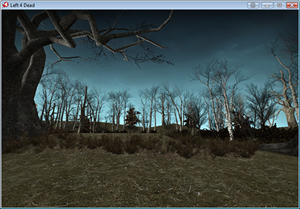

### Fog of Horror

Fog is a very important part of your Left 4 Dead map. Fog can set the mood of the map, give it depth, and also help to make it so your map doesn't have to be massive. To get fog into a map all you need is to add is the point entity: "**env_fog_controller**". Getting fog to look "correct" can be tricky. A good method for making the fog look seamless is to set the color to a to a shade similar to your skybox texture. To determine what color to use I took a screenshot of my current map in game, and then used a color picker in a photo editing program to determine the color of the skybox image. In this case we chose a color close to the top of the skybox where the sky is dark. Our number ended up being **"10 15 18**". Ensure that "**Fog Enable**" is set to "Yes".

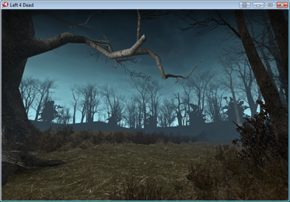

Set the **fog start distance** to a low number such as **128**, and set the **fog end distance** to a number around **900**. This should ensure that all the trees near the edge of the map look dark and silhouetted against the skybox. Silhouettes are an useful design feature in Left 4 Dead. Using them you can help guide the player, give the look of far off buildings or hills, and generally set a scary mood in your map.

### Final Environment Touches

You now have a larger forest and fog that helps darken the trees in the distance. But you still can see a very hard edge where the terrain meets the edge of the skybox. Since we will never let the player anywhere close to this area, there is no need to use complex 3D trees to try and blanket the edge of the map. Instead you can use a 2D texture to simulate a larger forest beyond. Select the **NoDraw texture**, and then make a new brush object along the edge of the map. Set the length and height of the brush to **1024**, and the depth to a lower number such as **32**.

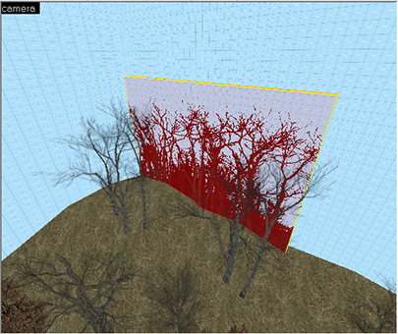

Open the **Texture application** and search for "**Trees**". You will find a few different tree textures. Select the inside face of the brush and apply the new texture. Under "**Justify**" press the "**Fit**" button to make the new texture fit the brush. The texture scale should end up a exactly "**1.00**". This will ensure the trees don't end up squashed or stretched to the point that they look bad in the game. Move the brush up and down until it looks like it naturally intersects the terrain. Inside the 2D view you can copy the brush easily by selecting it, and holding SHIFT while dragging the brush over to a new position. In this way you can create the look of more woods fully surrounding your map.

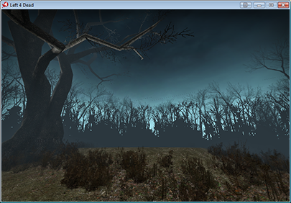

### Func_detail Explained

Up until now our map has been one massively large single room with just six sides. The problem is that the new surrounding tree textured brushes will cut our single room into multiple pieces. This is due to the way **Binary Space Partitioning** works. In order to restore out large single room, we need to tell Hammer what objects in the world do not need to block the rendering of objects behind them. Any brush in the map that can block the players view and cut the map into more pieces is called a "**World brush**". Since the trees we added have a partially transparent texture we can assume that they don't need to block the view of the player. These types of world brushes can be converted in to a **func_detail**. To convert them, select each of the tree textures brushes and then press **CTRL+T**. The default entity that shows up is "**Func_detail**".

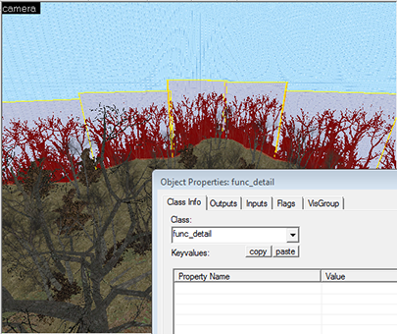

Using Func_Detail brushes properly can make or break the performance in a large map. Func_Detail should used anywhere there is a brush that is used to make a small detail, highly complex object, or does not significantly block the players view. For example: trim on a building, a pillar in the middle of a room, or a distant building. Func_detail brushes can also be misused. For example they will not seal a map from leaks. Since it doesn't block the rendering of objects beyond the func_detail if you were to use it for walls inside a building, the entire building might end up being rendered by the game engine no matter where you were inside of it.

### Visible and Invisible Barriers

In order to prevent the player from running beyond the trees and off to the edges of the map you need to block the player from traveling into these areas. You can do this by placing both visual barriers, and invisible barriers. For our visible barrier we will start by placing a "**prop_static**" near the edge of the forest. Then change the model to a fence. We selected: "**models/props/de_inferno/wood_fence.mdl**". We then copied the prop_static and rotated it until it surrounds my whole map. This gives the player a visual aid telling them they can't move past a certain point in the map. You should always strive to use a visual barrier of some sort when blocking a player in. An "invisible wall" alone is often frustrating for players who are suddenly stopped for no reason.

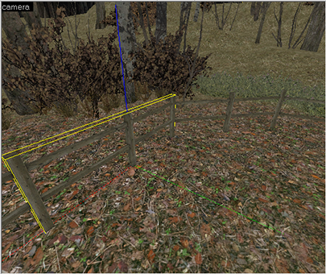

To place our invisible barrier we will use a special material called "**Player Clip**". Player clip is a material that blocks the travel of any human-controllable players in the game. It doesn't block zombies, bullets, or physical objects. Select the Player Clip material and then make a new brush object that is the same thickness as your fence. Place the brush such that it covers the whole fence model. I make sure that my player clips run all the way to the top of the skybox. This way there is no way for a player to jump over the invisible barrier.

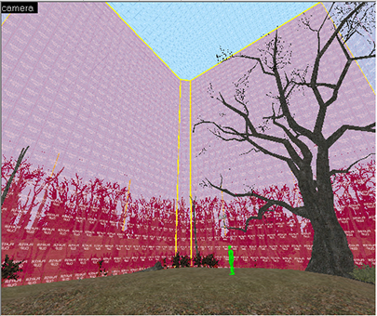

Clip brushes do not have to be converted to Func_detail. These and some other special materials are automatically converted by the compiler.

### Load Up with Weapons

In order for your players to fight off the hordes of zombies they will need some weapons. Weapons are a point entity, and can easily be found by searching for the entity class: "**weapon**". Place a few weapons near the player spawn. In the weapon properties set the count to **5**. This ensures the weapon will never disappear if all the players pick up the same gun.

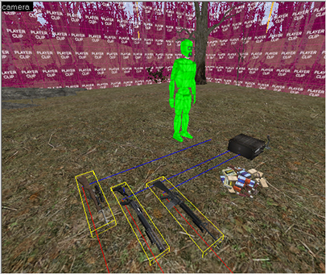

### Cube maps

A **cube map** is an important part of making a map look good. A cube map is a point entity that takes a 3D image of the world around it, and then maps this image onto reflective objects nearby. You typically place in the middle of a room, or near reflective objects such as glass or water. You should use them carefully as each cube map adds to the memory load of your map. A map requires a least one cube map. In our map we need only one for now, as we have only a single area, and light to worry about.

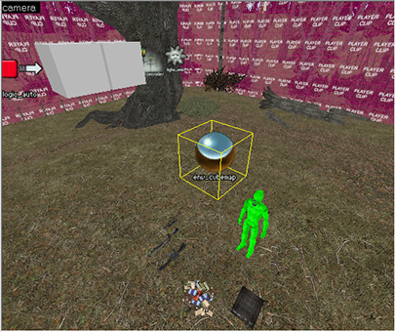

We have placed a cube map in the center of the map, about 200 units above the ground. Once you compile your map you enter the game console and type: "**build_cube_maps**" into the console. This will then take a series of screenshots and then exit the map. The cube maps are saved into the map file, and you only need to rebuild them if you make major changes to the map or lighting.

COMMENTS Login or register to post comments

avatar

dont work help??

Submitted by ryanemm93 on Fri, 02/05/2010 - 5:09pm

i followed the instructions step by step precisely

but when i click enter after creating the box and selected the texture, the box is not yellow and solid

it is just outlines....

anyone know anything aboout that ?????

Login or register to post comments

avatar

C-map

Submitted by linktocomputer on Wed, 02/03/2010 - 1:58am

C-map - Authorized distributor of c-map, c-map max, c-map nt+, navionics, livecharts, SeaPro

dodge parts

Login or register to post comments

avatar

importing materials

Submitted by J_man86 on Sat, 01/16/2010 - 11:06am

I'm trying to import the materials from l4d but when in sketchup under the plugin tab there is only 2 options in the drop down menu and they are both "export", so i don't know how to import the materials. please help.

Login or register to post comments

avatar

Re: Custom props

Submitted by ZapWizard on Tue, 12/29/2009 - 12:41pm

You package the custom props along with your final VMF, which is a sort of ZIP style packaged file with all the files related to your map or campaign.

Login or register to post comments

avatar

Great Work - Thanks!

Submitted by SMTB1963 on Tue, 12/29/2009 - 6:48am

After initially reading this article soon after it was published, I went searching for more L4D "how-to" stuff on the net...this is by far the best written & explained tutorial for those new to L4D modding I've found so far. Also, the links to the tools & utilities were great time savers.

Thanks MAXIMUMPC and Joshua Driggs!

ps - anyone reading this should check out ZAPWizard's other projects - he's definately into some cool stuff.

Login or register to post comments

avatar

Yellow Cubes

Submitted by mdpaustin on Thu, 12/24/2009 - 8:24pm

Pikalex,

Go to:

Tools->Options->3dViews

Increase the Model Render Distance and see if that solves the problem.

Login or register to post comments

avatar

custom props

Submitted by jackmueth on Wed, 12/23/2009 - 8:57pm

when using a custom prop, do i have to install the prop on every computer i use it on, or does the map save the model info within it?

Login or register to post comments

avatar

Yellow cubes instead of models?

Submitted by pikalex88 on Tue, 12/22/2009 - 6:52pm

This looks like a very interesting and detailed tutorial, but I'm having a problem on page 2. When I place the static prop tree models in the 3D window they appear as giant yellow cubes and I cannot actually see the tree model unless I move the camera inside the box, where it cannot see other models. In the picture from the tutorial multiple trees can be seen, how is this possible? Does anyone else have this problem or know what I'm missing? I also cannot see grass after I paint alpha within the 3D window, though when I run the game it is there. That isn't as big a problem, but could maybe be related?

A screenshot of my map running in Hammer if that helps is Here

Login or register to post comments

avatar

Did you make the outer most

Submitted by ZapWizard on Tue, 12/29/2009 - 12:44pm

Did you make the outer most cube of your world hollow?

As for the grass: Along the menu bar there is a setting to view everything as high quality, grass and leaves are hidden in all but the highest quality setting.

Login or register to post comments

avatar

"Fix the roof line"

Submitted by klewd on Tue, 12/15/2009 - 7:33pm

This is one of the best tutorials I've read, but unfortunately there is one point where I think it could be better explained. How do you make everything align suddenly at page 8? It's not aligned at page 7, and there's no prior explanation, that I can see at least.

Login or register to post comments

avatar

It is explained in the first

Submitted by ZapWizard on Sun, 12/20/2009 - 7:38am

It is explained in the first paragraph on page 8. What you need do is to cut the face at the edge of the balcony and then pull it out until the center of the roof line meets close to the center of the top of the block.

Login or register to post comments

avatar

Zap, first thanks for the

Submitted by mdpaustin on Sun, 12/20/2009 - 6:26pm

Zap, first thanks for the great tutorial. I too was having difficulty getting the roof center line adjusted. Once I clicked on "Project textures from photo" again, everything worked out.

M

Login or register to post comments

avatar

Wow

Submitted by emperor3d on Thu, 12/10/2009 - 9:29pm

You gotta give major props to MPC for this rather thorough tutorial. Very fine job indeed. Good job boys and girls.

Login or register to post comments

avatar

how

Submitted by hammerfell on Thu, 12/10/2009 - 8:06am

btw how different would this be from l4d2? can we do this using roughly the same process in l4d2?

Login or register to post comments

avatar

Just the same.

Submitted by ZapWizard on Fri, 12/11/2009 - 7:30am

I actually am in the beta for the L4D2 SDK, the steps to make a map and import assets is just the same as for L4D1.

Login or register to post comments

avatar

The maps you create will

Submitted by willsmith on Thu, 12/10/2009 - 12:19pm

The maps you create will work in L4D2 when the SDK comes out.

Login or register to post comments

avatar

Wow, one of the BEST

Submitted by Xylogeist on Thu, 12/10/2009 - 7:54am

Wow, one of the BEST how-to's by far.

Login or register to post comments

avatar

Too bad nobody actually

Submitted by lunchbox73 on Thu, 12/10/2009 - 7:04am

Too bad nobody actually plays Left 4 Dead anymore. Even weeks before the sequel there were hardly any games out there. Almost impossible to get a full versus game going.

Login or register to post comments

avatar

This guide will also work

Submitted by ZapWizard on Fri, 12/11/2009 - 7:45am

This guide will also work for the L4D2 SDK, or really any Source based game.

Login or register to post comments

avatar

No kidding, and this was

Submitted by DBsantos77 on Thu, 12/10/2009 - 8:43am

No kidding, and this was when STEAM had a $7 special on the first one.

:/

-Santos

Teh Rig:

AMD Phenom 720 (Unlocked to Quad, Stable @ 3.6 Ghz 1.47v)

Gigabyte Micro ATX 785gx Motherboard

G.Skill 4GB 1333 DDR3 8-8-8-21 @ 1.6v

HIS ATI Radeon HD4670 (CCC OC'd)

550w Corsai

Login or register to post comments

avatar

kudos

Submitted by hammerfell on Thu, 12/10/2009 - 6:21am

Definitely one of the coolest how too articles ever! I'm totally making my house Into an L4D level... and then after that... My friend's house... and after that... anything I can get blue prints and pictures of O_O

Login or register to post comments

avatar

work

Submitted by Yusonice on Thu, 12/10/2009 - 4:51am

Too much work!

Ill sticck to downloading the maps

Login or register to post comments

avatar

Great level of detail. Now

Submitted by Veritas19 on Wed, 12/09/2009 - 9:57pm

Great level of detail. Now do one for Team Fortress 2!

Login or register to post comments

avatar

This has to be the most epic

Submitted by vistageek on Wed, 12/09/2009 - 9:27pm

This has to be the most epic and well done how to i have ever seen. Great job. Tanks so much! (pun intended)

Login or register to post comments

avatar

This is sick, is there

Submitted by DBsantos77 on Wed, 12/09/2009 - 7:45pm

This is sick, is there anyway to achieve this by making models in 3DS or Maya?

-Santos

Teh Rig:

AMD Phenom 720 (Unlocked to Quad, Stable @ 3.6 Ghz 1.45v)

Gigabyte Micro ATX 785gx Motherboard

G.Skill 4GB 1333 DDR3 8-8-8-21 @ 1.6v

HIS ATI Radeon HD4670 (CCC OC'd)

550w Corsai

Login or register to post comments

avatar

or

Submitted by nekollx on Thu, 12/10/2009 - 3:24pm

or Daz/Cararra/Poser?

------------------------------

Coming soon to Lulu.com --Tokusatsu Heroes--

Five teenagers, one alien ghost, a robot, and the fate of the world.

Login or register to post comments